Lab - Create User Accounts

# Introduction

In this lab, you will create and modify user accounts in Windows.

Part 1: Creating a New Local User Account

Part 2: Reviewing User Account Properties

Part 3: Modifying Local User Accounts

# Required Resources

* A Windows PC

# Instructions

## Creating a New Local User Account

### Open the User Account Tool.

* + - 1. Log on to the Windows PC with an Administrator account. The account **CyberOpsUser** is used in this example.
      2. Click **Start** > search **Control Panel**. Select **User Accounts** in the Small icons view. To change the view, select **Small icons** in the View by drop down list.

### Create a user account.

* + - 1. In the **User Accounts** window, click **Manage another account**.

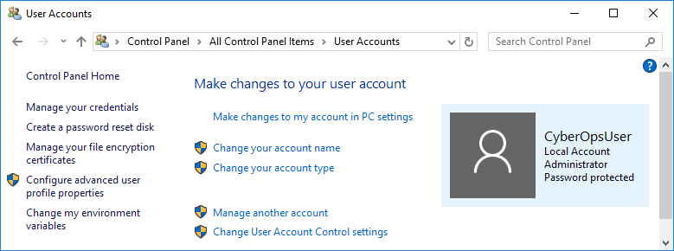

* + - 1. In the **Manage Accounts** window, click **Add a new user in PC settings**.
      2. In the **Settings** window, click **Add someone else to this PC**.
      3. In the **How will this person sign in?** window, click **I don't have this person's sign-in information**.
      4. In the **Let's create your account** window opens, click **Add a user without a Microsoft account**.
      5. In the **Create an account for this PC** window, provide the necessary information to create the new user account named **User1**. Click **Next** to create the new user account.

#### Question:

What type of user account did you just create?

Type your answers here.

* + - 1. Attempt to log into the newly created user account. It should be successful.
      2. Navigate to **C:\Users** folder. Right-click the **User1** folder and select **Properties**, and then the **Security** tab.

#### Question:

Which groups or users have full control of this folder?

Type your answers here.

* + - 1. Open the folder that belongs to CyberOpsUser. Right-click the folder and click the **Properties** tab.

#### Question:

Were you able to access the folder? Explain.

Type your answers here.

* + - 1. Log out of User1 account. Log back in as CyberOpsUser.
      2. Navigate to **C:\Users** folder. Right-click the folder and select **Properties**. Click the **Security** tab.

#### Question:

Which groups or users have full control of this folder?

Type your answers here.

## Reviewing User Account Properties

* + - 1. Click **Start** > Search for **Control Panel** > Select **Administrative Tools** > Select **Computer Management**.
      2. Select **Local Users and Groups**. Click the **Users** folder.

Screenshot of Computer Management showing the Users folder.


* + - 1. Right-click **User1** and select **Properties**.
      2. Click the **Member Of** tab.

#### Question:

Which group is User1 is a member of?

Type your answers here.

* + - 1. Right-click the account CyberOpsUser and select Properties.

#### Question:

Which group is this user a member of?

Type your answers here.

## Modifying Local User Accounts

### Change the account type.

* + - 1. Navigate to the **Control Panel** and select **User Accounts**. Click **Manage another account**. Select **User1**.
      2. In the Change an Account window, click the **User1** account. Click **Change the account type**.
      3. Select the **Administrator** radio button. Click **Change Account Type**.
      4. Now the account User1 has administrative rights.
      5. Navigate to **Control Panel** > **Administrative Tools** > **Computer Management**. Click **Local Users and Groups**> **Users**.
      6. Right-click **User1** and select **Properties**. Click **Member Of** tab.

#### Question:

Which groups does User1 belong to?

Type your answers here.

* + - 1. Select **Administrators** and click **Remove** to remove User1 from the Administrative group. Click **OK** to continue.

### Delete the account.

* + - 1. To delete the account, right-click **User1**and select **Delete**.

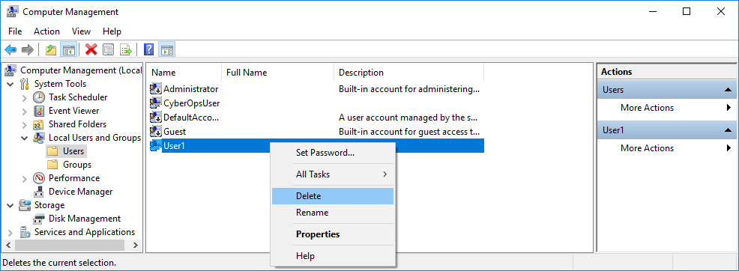

* + - 1. Click **OK** to confirm the deletion.

#### Question:

What is another way to delete a user account?

Type your answers here.

# Reflection Questions

* 1. Why is it important to protect all accounts with strong passwords?

Type your answers here.

* 1. Why would you create a user with Standard privileges?

Type your answers here.

End of document